# METEOR manual vs 2019.0.0

## Login

1. Open <https://meteorapplication.com/Account/Login> in your browser an select your site:

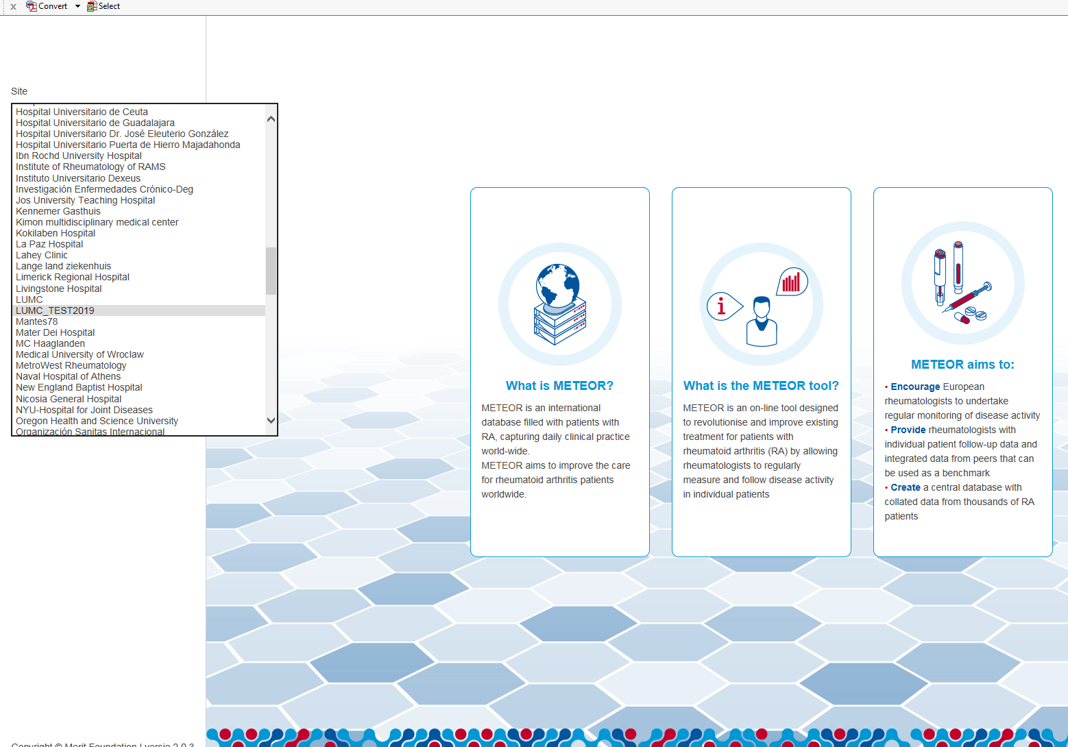

1. First you have to install Google Authenticator on your phone (Android/iPhone). This is needed for the 2-step verification process

Here is how to install the app:

<https://support.google.com/accounts/answer/1066447?co=GENIE.Platform%3DiOS&hl=en>

1. When you have installed the Google Authenticator app you can read the QR code which shows up on the first time when you log in on your METEOR site.

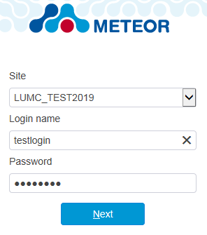

The Google Authenticator app will generate codes to log in:

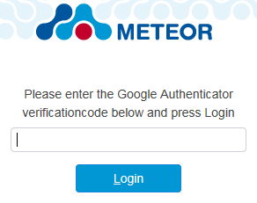

1. After entering the verification code you will have access to your site:

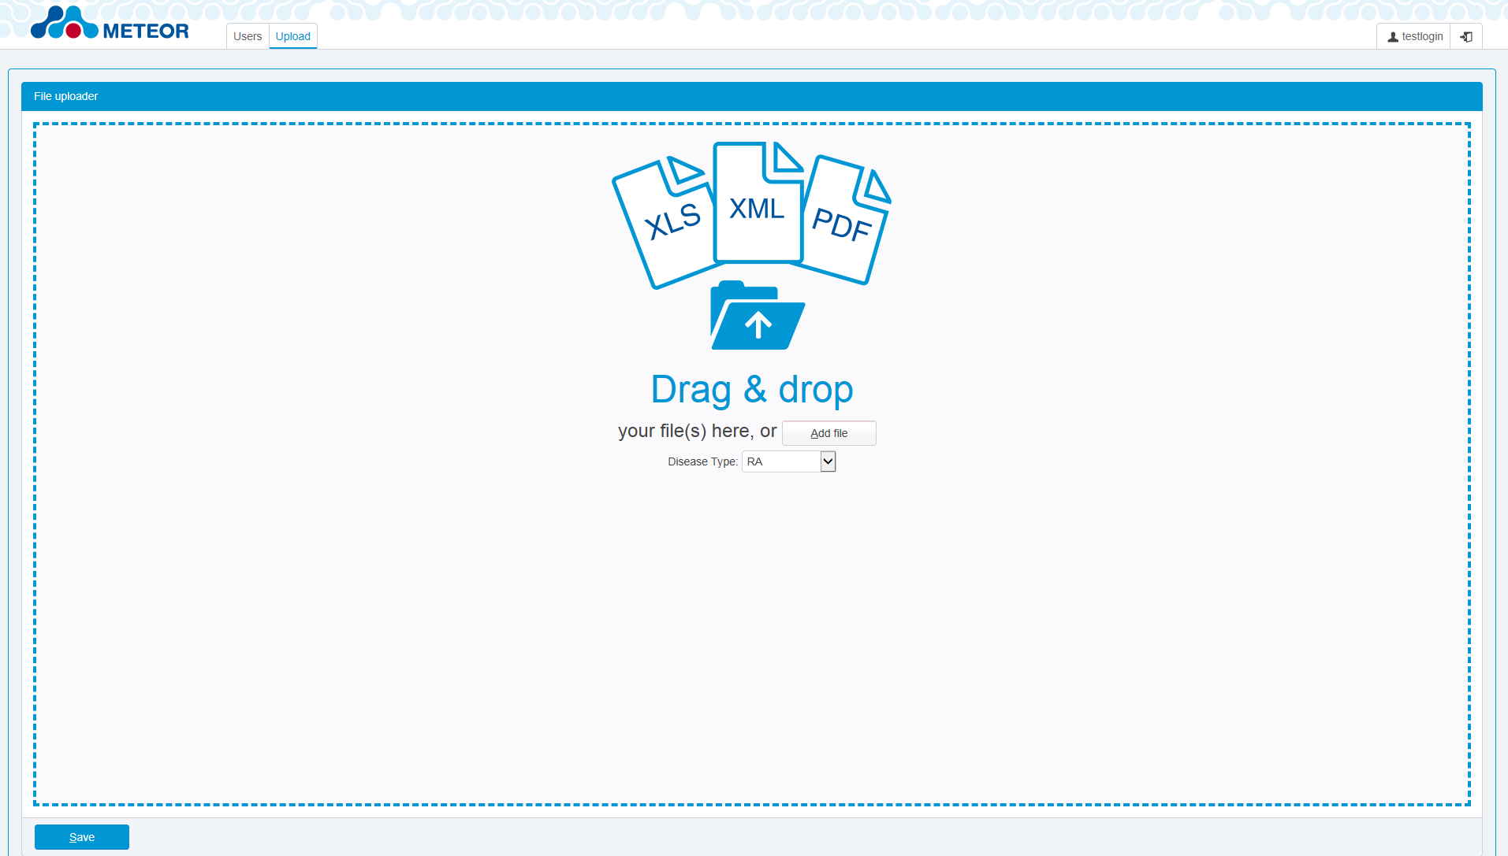

1. You will have either SiteAdministrator rights or SiteUser rights. As a SiteAdministrator you can add/edit and delete users:

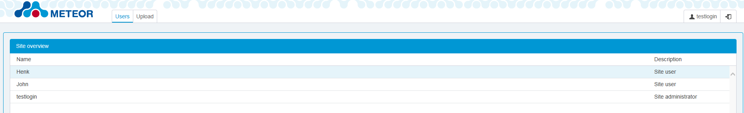

1. You can change their password or give users a different role as admin:

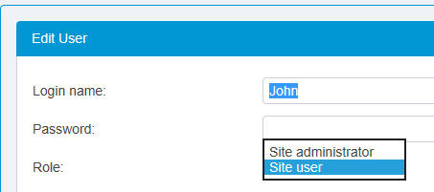

1. In the right upper corner you can log off or change your account settings:



Uploading files:

You can drag & drop your patientsfile (XLS, XML or PDF) into the central field of the site or use the add file button. Always use a recent file, they can be found at the tab downloads. Under this tab you can also find the manual for the site (will follow later/ICT). A short explanation on the different type of files and an extended explanation on the use of the PDF can be found at the end of this manual.

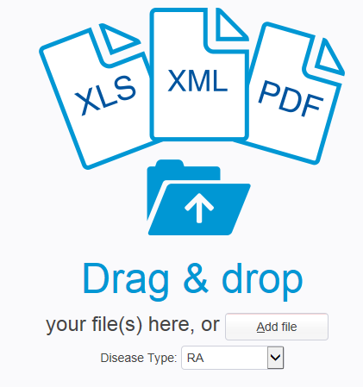

You also have to select the disease type here :



Click Save as you have entered your patientfile. The following message will pop-up:

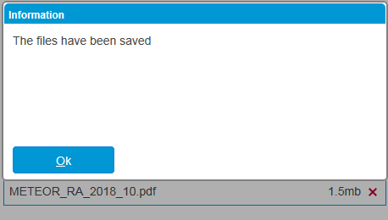

You can now enter a new one or log off.

Your file will be processed by the METEOR foundation. They will inform you if the entered data has to be corrected or fails to process.

## Information

To receive an extraction of the data you entered, which can be used for research or evaluation purposes, please contact [s.a.bergstra@lumc.nl](mailto:s.a.bergstra@lumc.nl) .

Send an email to info@meteorfoundation.com if you have any questions.

Feel free to contact us for further information, or visit our website: www.meteorfoundation.com for further details and our publications.

## How to use the upload files?

Data can be uploaded in METEOR in 3 ways:  
  
1. **XML:** Download from an existing electronic health record system or (research) database. The existing data can be converted to the predefined XML format and uploaded at the website. All required documents can be found at the tab downloads. The XML has not been changed compared to earlier versions of METEOR. If your site was already uploading data into METEOR, nothing will change to the XML or the data conversion. The only thing that has been changed is the website at which the data will be uploaded.  
2. **XLS**: Download from an existing electronic health record system or (research) database. The existing data can be converted to the predefined Excel file and uploaded at the website. The required documents can be found at the tab downloads. It is also possible to use the Excel file for direct data entry, although manual data entry through step 3 is more user friendly.  
3. **PDF**: Manual data entry using the digital PDF file. The PDF can be downloaded at the tab downloads, after which data can be entered digitally. No direct internet access is needed for data entry. After the pdf is completed, it can be saved and uploaded directly at the website.

## Manual data entry using PDF files.

For each visit a new PDF needs to be completed and saved. The red boxes indicate the minimum information that needs to be entered for each visit. Based on the information in the red boxes, information of several visits of each patient will be combined in the database.

## The rheumatoid arthritis and spondyloarthritis PDF

Below an extensive manual for the use of the RA and SpA PDF is available. Both PDF-files work similar, but have a different content.  
 **Saving and uploading**

After you entered all available data in the PDF, you can save it and upload it at the website. You can upload multiple PDF’s at once, for example once per week.

Keep in mind that the red boxes indicate the minimum information required for upload. If these are not completed, you will receive an error. This means that it is not obliged to complete for example the HAQ, if you do not measure this at every visit. However, the more information you enter, the more useful the data is for research purposes.

**Data extraction**If you want an extraction of the data, you can request this at any time, by sending an email at [s.a.bergstra@lumc.nl](mailto:s.a.bergstra@lumc.nl) . With the exception of holidays, you will receive your extraction within a week. The data in the extraction will be suitable for review, benchmarking or performing research.

## RA PDF

**Patient characteristics**

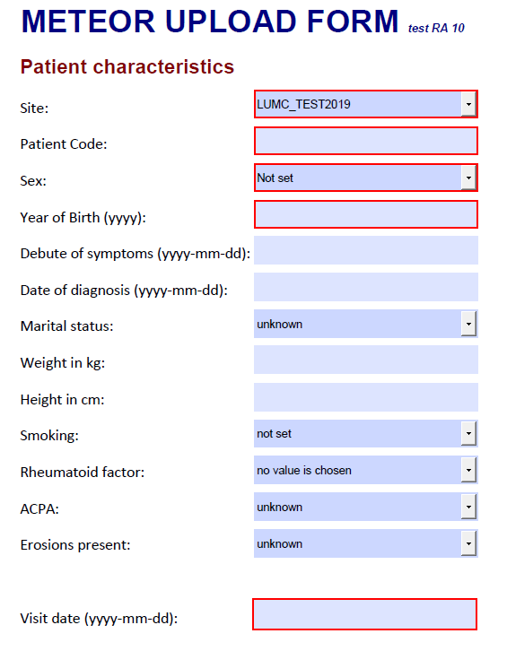

Scenario 1: at the first visit, all patient characteristics are completed. At each consecutive visit, only the information in the red boxes is entered.  
Scenario 2: at the first visit, all patient characteristics are completed, except for weight and height, which were not measured. At visit 2, weight and height were measured. Therefore the red boxes are completed, and information on weight and height is added. After uploading the PDF file for visit 2, this data will be automatically combined in the database. It is not needed to adjust the PDf file for visit 1 and upload it again.  
Scenario 3: at the first visit, all patient characteristics are completed. At visit 2, only the information in the red boxes was entered. At visit 3, the patient lost a lot of weight. The new weight is entered at visit 3. After uploading the PDF for visit 3, the weight for this patient will be adjusted in the database.

**Disease activity**

First indicate which type of DAS was measured: DAS28 based on 28 tender and swollen joints, or DAS based on 53 tender and 44 swollen joints. If no joints were tender, tick the box “no tender joints”. If no joints were swollen, tick the box “no swollen joints”.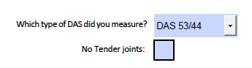

If there were tender joints, indicate this for each concerning joint (1=tender, 2=tender with wincing, 3=tender with wincing and withdrawal). The standard value is 0 (no tenderness).   
For the full DAS score, it is appropriate to use the 0 to 3 scale, in accordance with the Ritchie Articular Index. For the DAS28, it is sufficient to use the 0 and 1 values. If for the DAS28 a 2 or 3 is entered, we will convert this to 1 in the research database.

For the swollen joints, only the values 0 (not swollen) and 1 (swollen) are available for each joint. The standard value is 0.

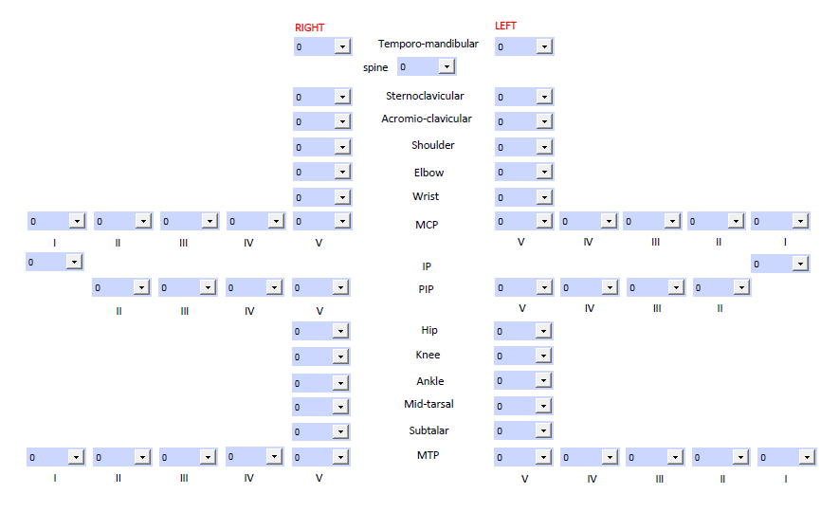

Information regarding VAS pain, VAS patient global disease activity and VAS physician global assessment can be entered on a scale from 0 to 10 in the appropriate box. ESR is entered in mm/h and CRP is entered in mg/L.

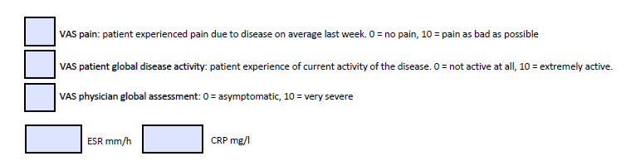

In contrast to the current online METEOR tool, we can unfortunately not automatically calculate disease activity indices such as the tender and swollen joint counts and composite scores such as the SDAI, CDAI and DAS(28) within the PDF. When you upload the PDF files, we will use all information you entered to automatically calculate these values in the research database.  
If you want to, you can calculate the composite scores of your interest and enter them in the appropriate box. This is not needed, but it may be helpful for your own review.  
On the other hand, it is possible that you do have information on a full composite score, such as the DAS28, but not on its components. In that case, you can also enter the full score below.



**HAQ/RAPID3**

All individual questions for the HAQ can be entered, including help from another person and aids or devices needed.

Just as for the disease activity composite scores, the total HAQ is not automatically calculated within the PDF. When you upload the PDF files, we will use all information you entered to automatically calculate the HAQ in the research database.You can enter the full score for your own review. If you only have information available on the total HAQ score, but not on the individual questions, you can also only enter the full score.

**EQ5D**The EQ5D is a new questionnaire available in METEOR. It can be completed by ticking the appropriate box for each category. The EQ5D measures health-related quality of life and is used in amongst others cost effectiveness analyses.

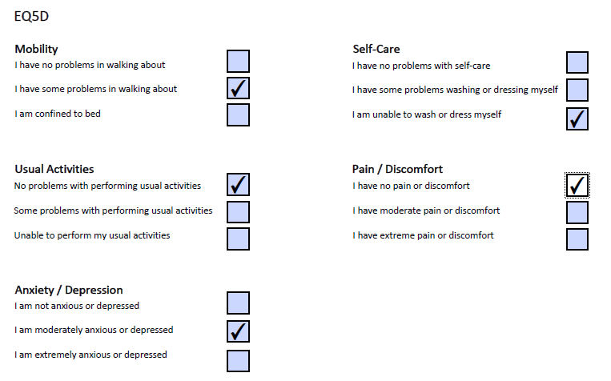

**Medication**

Medication is divided into several subcategories: csDMARDs, biologicals, JAK-inhibitors, corticosteroids, NSAIDs, non-NSAIDs and other.

If no medication is used, tick the box “no medication”. Otherwise, complete the appropriate information regarding drug type, dose and interval, start and stopdate and if applicable, the stopping reason.

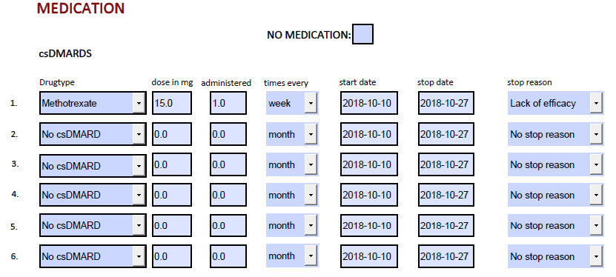

In case of a biosimilar, also the product name can be entered.

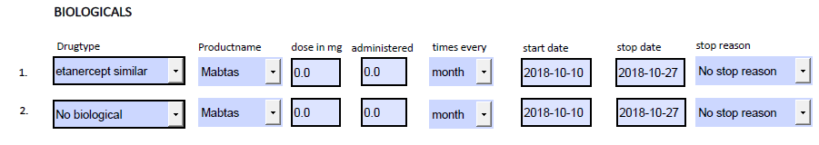

**Comorbidities**

The entry of comorbidities in METEOR has been simplified. You can now tick the appropriate box, which is in accordance with the EULAR recommendations for observational databases and registries. If the comorbidity does not fit into one of the boxes, you can enter the name as free text in the textbox.   
Please ensure that only the name of the comorbidity is entered and that the box contains no privacy related information, since all information in this box will be uploaded.

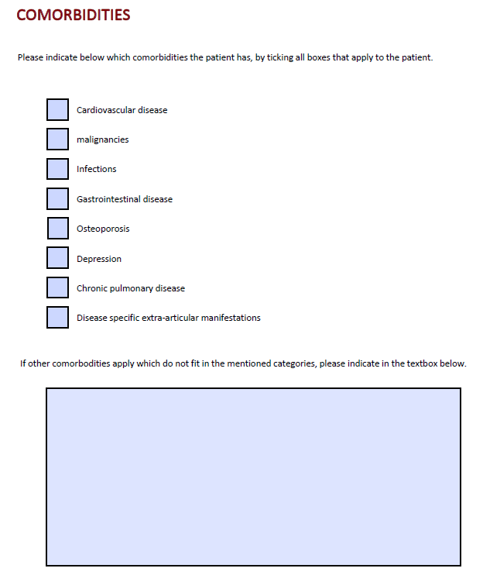

**Free text**

If you want to add any information for own review, this can entered at the bottom of the PDF file in the free text box. Information in this box is not uploaded, and may thus contain privacy related information.

## SpA PDF

**Patient characteristics**

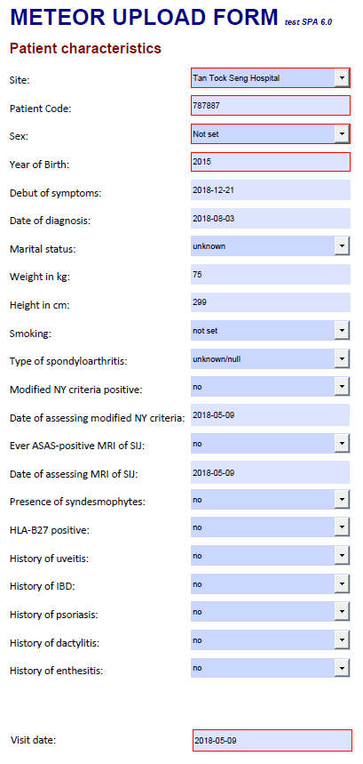

Scenario 1: at the first visit, all patient characteristics are completed. At each consecutive visit, only the information in the red boxes is entered.  
Scenario 2: at the first visit, all patient characteristics are completed, except for weight and height, which were not measured. At visit 2, weight and height were measured. Therefore the red boxes are completed, and information on weight and height is added. After uploading the PDF file for visit 2, this data will be automatically combined in the database. It is not needed to adjust the PDf file for visit 1 and upload it again.  
Scenario 3: at the first visit, all patient characteristics are completed. At visit 2, only the information in the red boxes was entered. At visit 3, the patient lost a lot of weight. The new weight is entered at visit 3. After uploading the PDF for visit 3, the weight for this patient will be adjusted in the database.

**Disease activity and physical functioning**

First indicate which joint count was measured: 28 tender and swollen joints, 53 tender and 44 swollen joints, or 68 tender and 66 swollen joints. If no joints were tender, tick the box “no tender joints”. If no joinst were swollen, tick the box “no swollen joints”.

**C:\Users\sabergstra\Pictures\joint count.PNG**

If there were tender joints, indicate this for each concerning joint (1=tender, 2=tender with wincing, 3=tender with wincing and withdrawal). The standard value is 0 (no tenderness). If necessary for the calculation of a full joint count, the values 2 and 3 will be converted to a 1 in the research database.  
For the swollen joints, only the values 0 (not swollen) and 1 (swollen) are available for each joint. The standard value is 0.

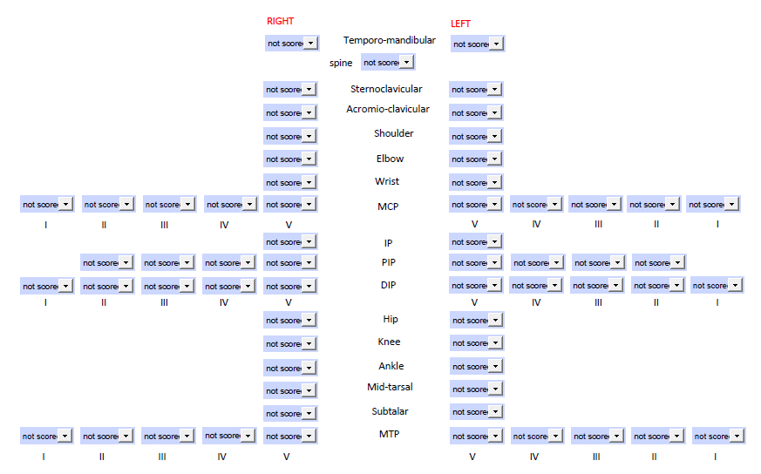

Information regarding patient and physician global assessment of wellbeing can be entered in the appropriate box. Both are measured on a scale from 0 to 10 in which 10 is the worst score. ESR is entered in mm/h and CRP is entered in mg/L.   
If you entered all individual tender and swollen joints, we will automatically calculate the full joint counts in the research database. If no individual tender and swollen joints are available, but only the full joint counts, you can enter these in the boxes “swollen joint count” and “tender joint count”. If you dose so, please do no forget to indicate which type of joint count you measured. Although it is not needed, you may also calculate and enter these joint counts for your own review.

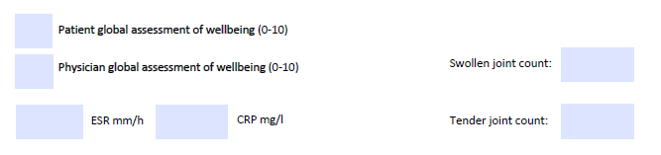

All individual components of the ASDAS can be entered in the appropriate box. Question 1 till 4 are scored on a scale of 0 to 10, in which 10 is the worst score. For the duration of morning stiffness, 0 means no morning stiffness and 10 means more than 2 hours of morning stiffness.  
The total ASDAS score will be automatically calculated in the research database. If the individual components of the disease activity score are unknown, you an also only enter the total ASDAS score in the box “ASDAS total”. Although not needed, you may also enter the total score for your own reference.

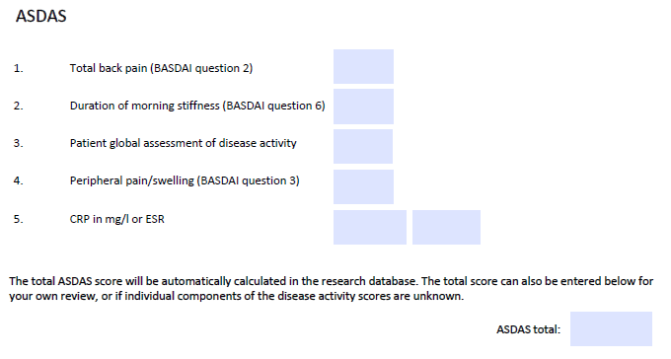

Presence of uveitis, IBD, psoriasis, dactylitis and enthesitis at each visit can be entered in the boxes as displayed below.

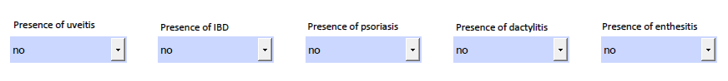

All individual questions of the ASAS health index can be completed at page 4. The standard entry is “not scored”. The total ASAS score will be automatically calculated in the research database. If the individual components of the disease activity score are unknown, you can also only complete the total score. Although not needed, you may enter the total score for your own review as well, even if you completed all individual components.

In addition to the original 17 questions of the ASAS health index, also the ASAS health index environmental factor item set can be completed.

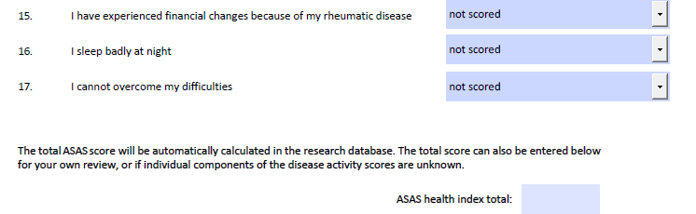

The BASDAI and BASFI can be entered at page 5. Again, all individual questions can be entered, or if only the total scores are available without the individual questions, only the total score can be entered. The total scores will automatically be calculated in the research database if you entered all individual questions. It is allowed to enter the total score for your own review as well.  
All questions are measured on a scale of 0 to 10, in which 10 is the worst score. For BASDAI question 6, 0 means 0 hours and 10 means 2 hours or more.

**EQ5D**The EQ5D is a new questionnaire available in METEOR. It can be completed by ticking the appropriate box for each category. The EQ5D measures health-related quality of life and is used in amongst others cost effectiveness analyses.



**Medication**

Medication is divided into several subcategories: csDMARDs, biologicals, JAK-inhibitors, corticosteroids, NSAIDs, non-NSAIDs and other.

If no medication is used, tick the box “no medication”. Otherwise, complete the appropriate information regarding drug type, dose and interval, start and stopdate and if applicable, the stopping reason.



In case of a biosimilar, also the product name can be entered.



**Comorbidities**

The entry of comorbidities in METEOR has been simplified. You can now tick the appropriate box, which is in accordance with the EULAR recommendations for observational databases and registries. If the comorbidity does not fit into one of the boxes, you can enter the name as free text in the textbox.   
Please ensure that only the name of the comorbidity is entered and that the box contains no privacy related information, since all information in this box will be uploaded.



**Free text**

If you want to add any information for own review, this can entered at the bottom of the PDF file in the free text box. Information in this box is not uploaded, and may thus contain privacy related information.