Newsletter February 2016
METEOR aims to improve treatment of rheumatoid arthritis worldwide and to demonstrate the value of regularly measuring disease course by offering the METEOR tool to aid physicians in quickly assessing patient improvement and comparing results through access of aggregated anonymized data collected by their peers.

ACR 2015
During the annual ACR meeting last November in San Francisco, dr. Karen Salomon-Escoto presented a poster entitled ‘TNF inhibitor use across countries in two time periods using the METEOR database’. In their study, Salomon-Escoto and colleagues compared the prescription of TNF inhibitors among patients with rheumatoid arthritis during two different time periods (July 2009-June 2010 and July 2011-June 2012), hypothesizing that the relative distribution of TNF inhibitor prescriptions may vary among countries (USA and European countries) with different healthcare systems. The relative prescription of various TNFi, as recorded in the METEOR database, differed significantly across several EU countries and the US during two distinct time periods. Infliximab was prescribed significantly more often than other TNFi at sites in those EU countries examined compared to the US sites in period 1. In Italy and Portugal, etanercept was prescribed significantly more than other TNFi in period 2, compared to period 1 (Salomon-Escoto K et al. TNF Inhibitor Use Across Countries in Two Time Periods Using the Meteor Database [abstract]. Arthritis Rheumatol. 2015; 67 (suppl 10). http://acrabstracts.org/abstract/tnf-inhibitor-use-across-countries-in-two-time-periods-using-the-meteor-database/).
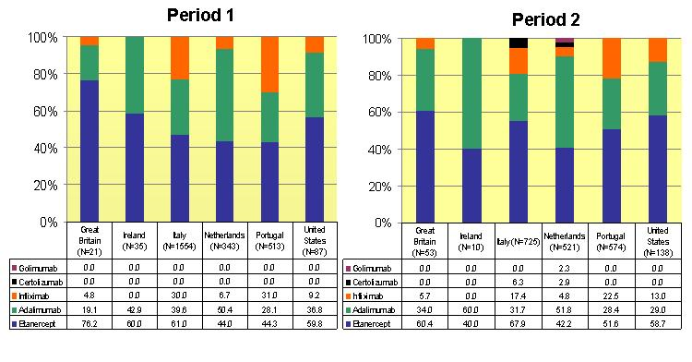

Did you know….
… that we have changed the drug entering module to make it easier for you? It is not necessary anymore to choose pre-specified ‘drug packages’, so there is no need anymore to calculate the number of tablets to come to the total dosage. You only need to fill out the total dosage of the medication the patient is using. This saves you time, and it overcomes potential errors in the database.
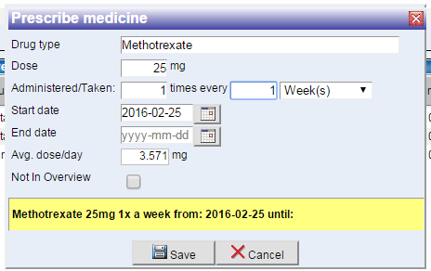
… that we have added the option to register the use of biosimilars? This can be done in two ways. By either registering the ‘drug type’ (e.g. an etanercept similar) or by registering the specific ‘drug brand’ (the ‘drug productname’ in the field below).
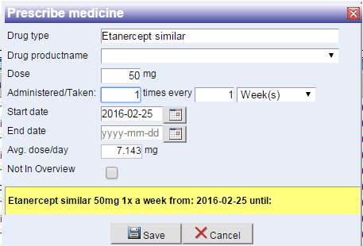
… that we need your help to complete the list of available biosimiliar brands across the world? So, if you are prescribing biosimilars for your patients, please provide us the brand names of these biosimilars so we can add them to the METEOR tool and you can start register them.
… that we are working on improving the quality of the data in the METEOR database?
… that we already succeeded in improving some parts – with the help from all of your – but that we aim for an even higher standard?
… that METEOR already exists 10 years in 2016?!
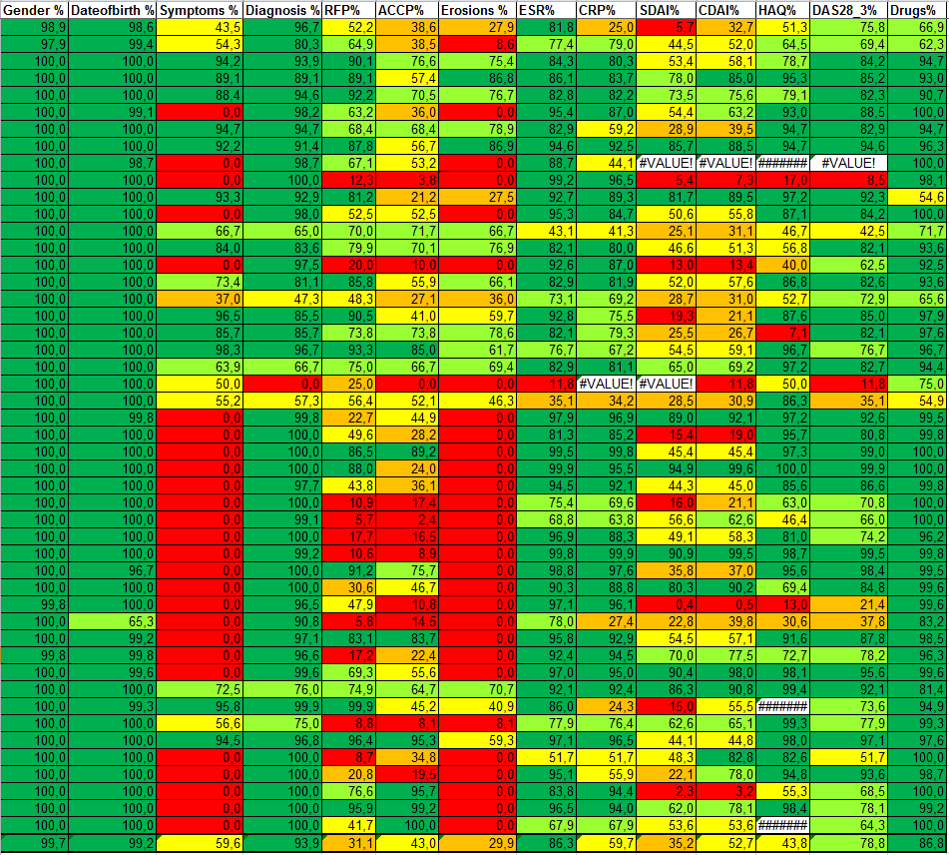
Heat map quality of data via upload. The last row represents the total quality of all uploaded data.
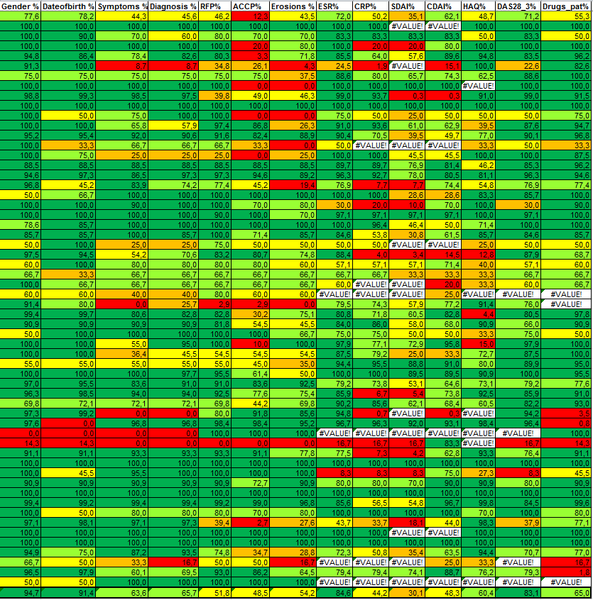
Heat map quality of data via upload. The last row represents the total quality of all uploaded data.

10 years METEOR
Ten years ago, some eminent experts (prof. Josef Smolen, prof. Ferry Breedveld, prof. Désirée van der Heijde, prof. Tom Huizinga, prof. Robert Landewé) in the field of rheumatoid arthritis sat down to discuss the possibilities of targeted treatment. It appeared that there was a need for a system in which rheumatologists could easily measure and monitor the disease course of their patients in order to be able to steer treatment to target. They came up with the ideal of having a free tool available to rheumatologists worldwide to aid rheumatologists in quickly assessing improvements (or worsening) of patients. Already in 2007, the METEOR tool was online! Since then, the data in the METEOR database has grown extensively, and several papers have been published based on data from the METEOR database.

First PhD thesis based on the METEOR database
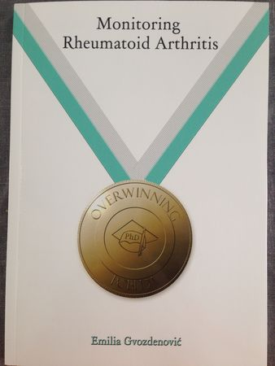
On Thursday March 31st 2016, Emilia Gvozdenovic will defend her thesis entitled ‘Monitoring Rheumadoid Arthritis’ in Leiden, the Netherlands. This is the first PhD thesis that almost solely contains chapters based on the METEOR database!
Emilia started as a PhD researcher in the Leiden University Medical Center in 2011. Her supervisors were prof. Robert Landewé, prof. Désirée van der Heijde and dr. Renée Allaart. The chapters of her PhD thesis are published in leading rheumatology journals and are therefore accessible to all of you (Gvozdenovic et al. DAS steered therapy in clinical practice: cross-sectional results from the METEOR database. BMC Musculoskelet Disord 2016;17:33. Gvozdenovic et al. Assessment of global disease activity in rheumatoid arthritis by patients and physicians: differences across countries in the METEOR database. J Clin Rheumatol 2015;21:349-54. Gvozdenovic et al. Assessment of global disease activity in RA patients monitored in the METEOR database: the patient’s versus the rheumatologist’s opinion. Clin Rheumatol 2014;33:461-6).
New board member
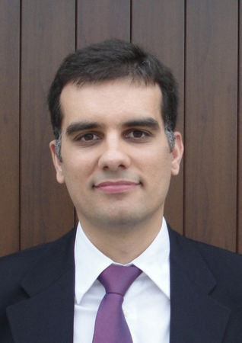
Since the first of October 2015, prof. Paul Emery rotated off as a board member. He is replaced by dr. Pedro Machado. Pedro undertook is medical and specialty training in rheumatology at Coimbra University Hospital, in Coimbra, Portugal. In 2010, Pedro started as a PhD researcher at the Leiden University Medical Center, Leiden, the Netherlands with a focus on musculoskeletal imaging and outcomes research in axial spondyloarthritis. He has since then moved to the UK and is now a National Institute for Health Research (NIHR) Researcher at University College London and Honorary Consultant Rheumatologist at University College London Hospitals, London, UK. Besides his research interest in rheumatoid arthritis, he is also interested in spondyloarthritis and myositis. With his expertise in performing research in longitudinal data, Pedro is an asset for the METEOR board, as he will supervise several research projects performed within the METEOR database. We all welcome Pedro to the METEOR board!

EULAR 2016
During the annual EULAR meeting in London in June 2016, METEOR will have a booth again. Since we will have some milestones to celebrate (see the topics ’10 years METEOR’ and the ‘First PhD thesis based on the METEOR database’ earlier in this newsletter), we will organize a social event at the booth. You will be further informed later on. We hope to see you all at our booth to celebrate with us. Please feel welcome to visit us at booth V18!

