**Newsletter September 2017**

*METEOR aims to improve the treatment of rheumatoid arthritis worldwide and to demonstrate the value of regularly measuring disease course by offering the METEOR tool to aid physicians in quickly assessing patient improvement and comparing results through access of aggregated anonymized data collected by their peers.*

**13th ESC meeting**

At Friday 8 September, the 13th ESC-meeting took place. During this meeting, METEOR users of several countries discussed the current status of METEOR, updates on research projects and future plans for METEOR.

During the meeting, it was shown that in August 2017, the METEOR database contained data on 37.327 patients and 190.071 visits. Of these, no less than 9.039 patients had complete data on patient characteristics, disease activity and medication during at least 4 visits.

Furthermore, the amount of scientific output is increasing. In 2016/2017 3 papers were published, 4 papers were submitted, 6 posters and 1 oral presentation were presented at international congresses and there are currently 9 ongoing research projects.

Lastly, we are pleased to announce that we are exploring the possibility of starting a METEOR spondyloarthritis cohort. If you regularly see spondyloarthritis patients in your clinic and you follow these patients longitudinally, for example through an electronic patient register, you could contribute anonymized information regarding these patients to the METEOR research database by regular uploads. For more information, please contact Sytske Anne Bergstra: [s.a.bergstra@lumc.nl](mailto:s.a.bergstra@lumc.nl).

**Comorbidities**

Did you know that you can enter reasons to stop a drug in METEOR? You can do this by clicking the ‘stop’ button below the list of active drugs. A pop-up screen will open, including the possibility to choose one of several stopping reasons.

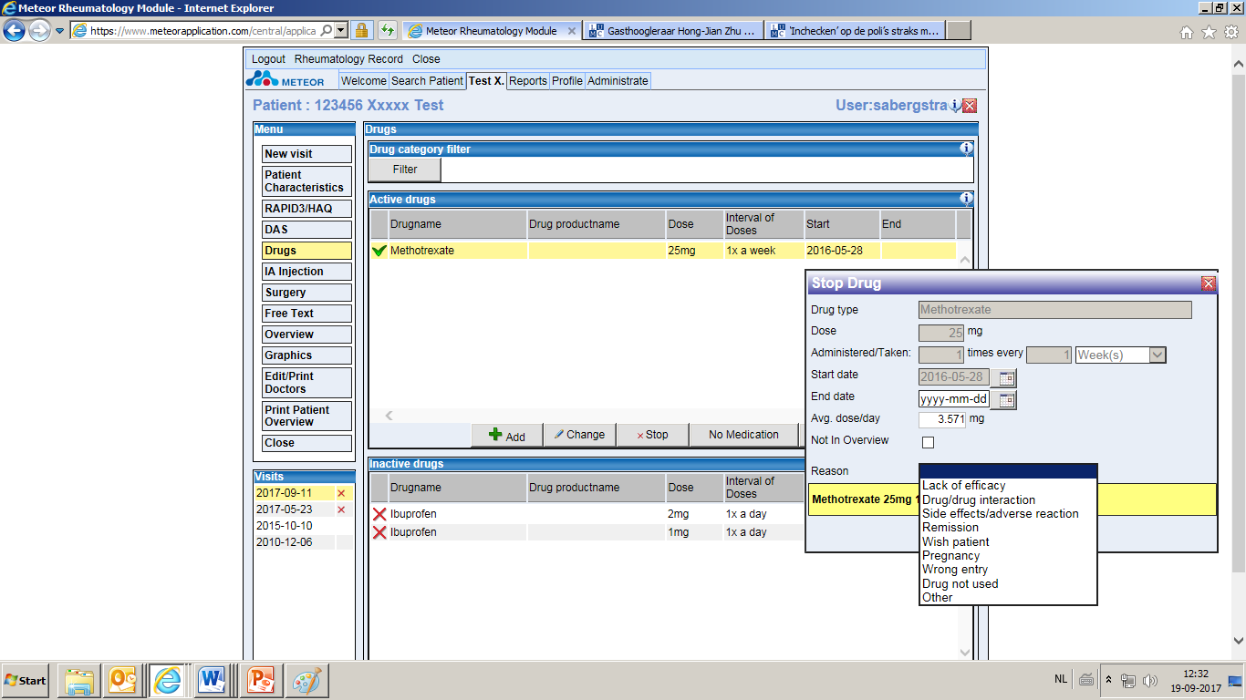

**METEOR tool versus METEOR upload**

Anonymized data regarding the treatment of rheumatoid arthritis patients is entered to the METEOR research database in two ways: through the free online METEOR tool and through upload of data.  
For hospitals that currently use the METEOR tool next to an existing electronic health record system or register, it may be interesting to switch from tool use to upload. This prevents a double entry burden.

If you want to switch from tool to upload, you will receive a standardised XML-file, together with a reference guide and additional documentation. Using this information, data can be converted from your local register into the correct format for upload into the database. During this process, a METEOR IT-expert is available to assist your local IT-expert. Once the process of data conversion has been established, data can be easily uploaded into the METEOR database on a regular basis. If you are interested in switching from tool to upload, please contact Sytske Anne Bergstra: [s.a.bergstra@lumc.nl](mailto:s.a.bergstra@lumc.nl).

**New METEOR members**

Recently, several new hospitals have decided to contribute to METEOR. One of these is the Shariati Hospital of Tehran University of Medical Sciences in Iran. The coordinator of METEOR in Iran is Toktam Kianifard.

*Why did you decide to join METEOR?*I believe that the best place for every research centre to gain further experience and advance their treatment is with a stable and well-respected international database. METEOR has a history of providing an excellent ability to capture daily pratice data and provide a big database which can help the rheumatologist to set up their aims and also share their experiences of the patients’ treatment.

*What do you hope to achieve by participating in METEOR?*We would like to be a part of the METEOR community and expand the relationship between rheumatologists and patients. It will be a great opportunity for TUMS to present our database to the world and to study our own RA and treatment responses and compare this to other countries. We also wish to study patient reported outcomes and quality of life issues and METEOR has the expertise and opportunities to help us with that.

**EULAR 2017**

At EULAR 2017, four abstracts were presented including METEOR data: one oral, two guided poster tours and one poster.

Similar short term clinical response to initial treatment with high versus low dose methotrexate in mono- and combination therapy in early rheumatoid arthritis patients.  
S.A. Bergstra, C.F. Allaart, R. van den Berg, A. Chopra, N. Govind, T.W.J. Huizinga, R.B.M. Landewé, on behalf of the METEOR working group.

Influence of patient global assessment on the disease activity assessment in patients with rheumatoid arthritis: a METEOR cross-sectional study.  
R. Ferreira, M. Ndosi, C. Duarte, P. Carvalho, A. Chopra, K. Salomon-Escoto, D. Vega, D. van der Heijde, P.M. Machado, J. Da Silva

Does seropositivity influence differentially drug discontinuation of biologic antirheumatic agents with non-anti-TNF mode of action?  
A. Finckh, D. Courvoisier, J.E. Gottenberg, X. Mariette, J. Morel, S.A. Bergstra, V. Hernandez, C. Codreanu, T.K. Kvien, M.J. Santos, K. Pavelka, M. Hetland, K. Chatzidionysiou, J. Askling, C. Turesson, C. Gabay, R. van Vollenhoven

Aiming for remission according to any of the rheumatoid arthritis disease activity indices is more important for physical function than the actual choice of index: a longitudinal analysis in a clinical practice setting (METEOR cohort)

P. D. Carvalho, R. Ferreira, R. Landewé, D. Vega-Morales, K. Salomon-Escoto, D. J. Veale, J. da Silva, P. M. Machado

You can find all recent publications in the METEOR website: <http://www.meteorfoundation.com/Publications.aspx>   
Full versions of each abstract are available in the EULAR abstract archive:   
<http://scientific.sparx-ip.net/archiveeular/?view=2&c=s>

**REQUEST FOR RESEARCH PROPOSALS**

Data that is entered into the METEOR research database is available for research for all actively contributing centres. If you are interested in performing research using the database, you can submit a research proposal. Proposals are assessed within one month by our Executive Scientific Committee on relevance, ethical considerations and feasibility. If you would like to receive the format for research proposals or if you have any questions regarding performing research in the METEOR database, please send an email to Sytske Anne Bergstra: [s.a.bergstra@lumc.nl](mailto:s.a.bergstra@lumc.nl).

Thank you for reading this newsletter. If you have any questions or remarks regarding METEOR, please contact Sytske Anne Bergstra: [s.a.bergstra@lumc.nl](mailto:s.a.bergstra@lumc.nl).